

Internship Report

Simulink Model of EV 4 Wheeler

**Project Guide**

*Dr. Dhiraj Kumar Mahajan – Department of Mechanical Engineering*

Submitted by – Somya Katoch

Intern

Submitted On- 12 June, 2025

### STUDENT DECLARATION

I **Somya Katoch** hereby declare that I have undertaken 2 months Industrial Training at **“Indian Institute Of Technology Ropar”** during a period from 14/05/2024 to 10/07/2024.

**Somya Katoch**

**Intern**

This is to certify that the above statement made by the candidate is correct to the best of my knowledge.

**Dr. Dhiraj Kumar Mahajan,**

**Department of Mechanical Engineering, IIT Ropar.**

### ACKNOWLEDGEMENT

I wish to thank my parents for financing my studies in this college as well as constantly encouraging me to learn engineering. Their personal sacrifice in providing this opportunity to learn engineering is gratefully acknowledged. I am really fortunate that I had the kind association as well as supervision of **Dr. Dhiraj Kumar Mahajan**.His exemplary guidance, constant encouragement, and careful monitoring throughout the training period are so great that, even my most profound gratitude is not enough.

### TABLE OF CONTENTS

**Chapters**

**Chapter 1:- Introduction 6**

1:1:- Overview of electric vehicles 1.1.1:- Types of EV

1.1.2:- Advantages of EV

1:2:- E-Car Model for Performance Simulation 1.2.1:- Key Components for model

1.2.2:- Valuable tools for model

**Chapter 2:- Block diagram… 9**

**Chapter 3:- EV Simulation Using Matlab Simulink… 11**

3:1:-Vehicle Body and Tires 3.1.1:- Description

3.1.2:- Vehicle Body Block 3.1.3:- Tires(Magic Formula)

* + 1. :- Gears
    2. :- Working for E- Car simulation
    3. 3.1.6:- Parameters

3:2:- Motor and Controller 3.2.1:- Motor

* + 1. :- H-Bridge
    2. :- Controlled PWM block
    3. :- Working for E- Car

3.2.5:-Parameters

3:3:- Driver Input

3.3.1:- Longitudinal Driver Block 3.3.2:- Multiple switch

* + 1. :- P-S Controller
    2. :- Parameters

3:4:- Regerative Braking Sytem

**Chapter 4:- Simulation Results… 28**

**Chapter 5:- Conclusion & Scope… 35**

* 1. Obtained parameters
  2. Conclusion

**Chapter 6:- References… 37**

# Introduction

##### Electric Vehicle:

Electric vehicles (EVs) are a rapidly growing segment of the transportation industry, offering a cleaner and more sustainable alternative to traditional gasoline-powered vehicles. An electric vehicle (EV) is a type of vehicle that is powered by electricity instead of gasoline or diesel. These vehicles use one or more electric motors to drive the wheels, and they store electricity in rechargeable batteries. EVs are becoming increasingly popular due to their potential to reduce greenhouse gas emissions and dependence on fossil fuels.

* + 1. **Types of electric vehicles:**

1. **Battery Electric Vehicles :** BEVs are powered solely by electricity stored in batteries. They do not have an internal combustion engine, and they must be plugged into an electric power source to recharge their batteries.
2. **Plug-in Hybrid Electric Vehicles (PHEVs):** PHEVs have both an electric motor and an internal combustion engine. They can operate on electricity alone for a limited range, after which the internal combustion engine takes over. PHEVs can be plugged in to charge their batteries or can rely on the engine to generate electricity.
   * 1. **Advantages of Electric Vehicle:**
        1. **Environmental Benefits:**EVs produce zero tailpipe emissions when running on electricity, reducing air pollution and greenhouse gas emissions.
        2. **Energy Efficiency:** Electric motors are more efficient than internal combustion engines, converting a higher percentage of energy from the grid into vehicle movement.
        3. **Lower Operating Costs:** Electricity is generally cheaper than gasoline or diesel fuel, resulting in lower fueling costs over the lifetime of the vehicle. Additionally, EVs have fewer moving parts than traditional vehicles, reducing maintenance needs and costs
        4. **Reduced Dependence on Fossil Fuels:** By using electricity as a fuel source, EVs can help reduce dependence on oil and contribute to energy independence.

### 4-Wheeler Electric Vehicle (EV) Model for Performance Simulation – In Simple Words

Four-wheeler electric vehicles (EVs) are an important step toward clean and eco-friendly transportation. Unlike cars that run on petrol or diesel, EVs use electric motors and batteries. They don’t produce harmful exhaust gases and help reduce pollution and the use of fossil fuels. That’s why they are becoming more popular around the world.

This report talks about a model of a 4-wheeler EV created using Simulink (a simulation tool). The model helps us understand how the vehicle performs under different road and driving conditions.

The model includes:

* **Vehicle Body:** It shows how the main structure of the car behaves when driving.
* **Motor and Controller:** This part simulates the electric motor and how it is controlled to speed up or slow down the car.
* **Tires and Suspension:** These are modeled to show how the car handles bumps, turns, and road grip.
* **Gear System (optional):** This allows us to see how different gear settings affect speed and performance.

This model is useful because it helps us:

* **Understand how the car works:** We can see how it speeds up, slows down, uses battery power, and handles different roads.
* **Test different designs:** We can try different motors, batteries, and gear setups to see what works best.
* **Improve the car’s control system:** We can develop smart ways to save battery and improve driving performance.

The goal of this report is to help in designing better electric cars. By using this model, engineers can test and improve different parts of the EV before building the real thing.

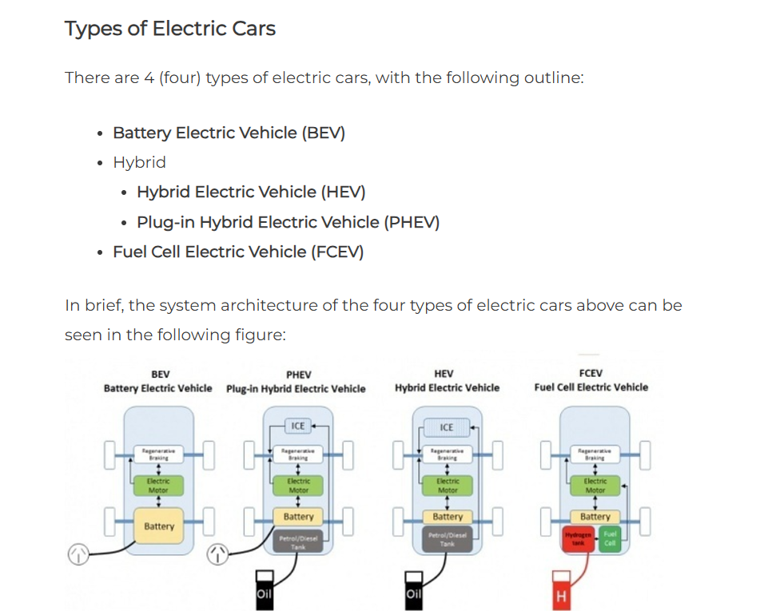

# Chapter 2: Block Diagram

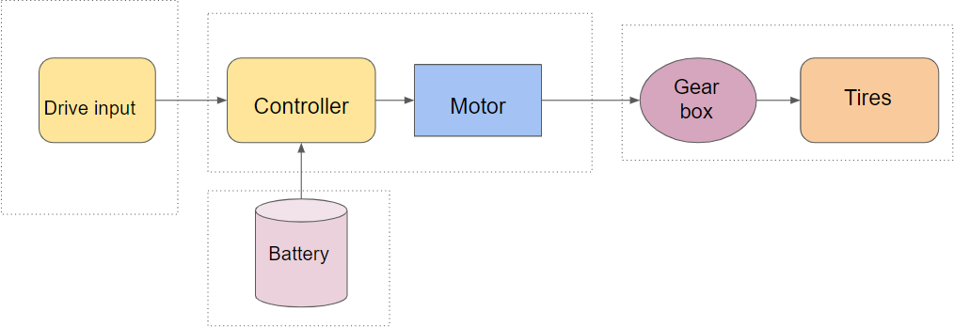

Block Diagram of Model of EV Bicycle

The image you sent is a block diagram of a typical electric bicycle (e-bike) system. It depicts the main electrical components working together to propel the bike. Here's a brief explanation of each component:

* **Battery:** The e-bike battery supplies the electrical energy to power the motor. Common battery types in e-bicycles include lithium-ion batteries, known for their high efficiency and long lifespan.
* **Drive Input:** This block likely refers to the mechanism used by the rider to control the motor's assistance level, such as a handlebar throttle or pedal-assist sensor. In a throttle system, the rider twists a grip to control motor power. In a pedal-assist system, the motor engages when the rider starts pedaling and provides increasing assistance as the rider pedals harder.
* **Controller:** The controller is the brain of the e-bicycle system. It receives signals from the drive input and battery, and then regulates the power delivered to the motor. The controller ensures safe operation by monitoring battery voltage and current to prevent overload.
* **Motor:** The electric motor converts electrical energy from the battery into mechanical energy to rotate the wheels. Brushless DC motors are commonly used in e-bicycles due to their efficiency and reliability.
* **Gear Box (Optional):** Some e-bicycles include a gearbox between the motor and the drivetrain to adjust the motor's output torque and speed to optimize riding efficiency.
* **Tires:** The e-bicycle tires provide grip and absorb bumps on the road surface

# Chapter 3: EV Simulation Using Matlab Simulink

**Here the entire simulation system is divided into four subsystems**.

1. The first subsystem contains the vehicle body and Tires.
2. The second subsystem contains the motor and controller circuit.
3. The third subsystem contains the driver input.
4. The Fourth subsystem contains the Signal input .

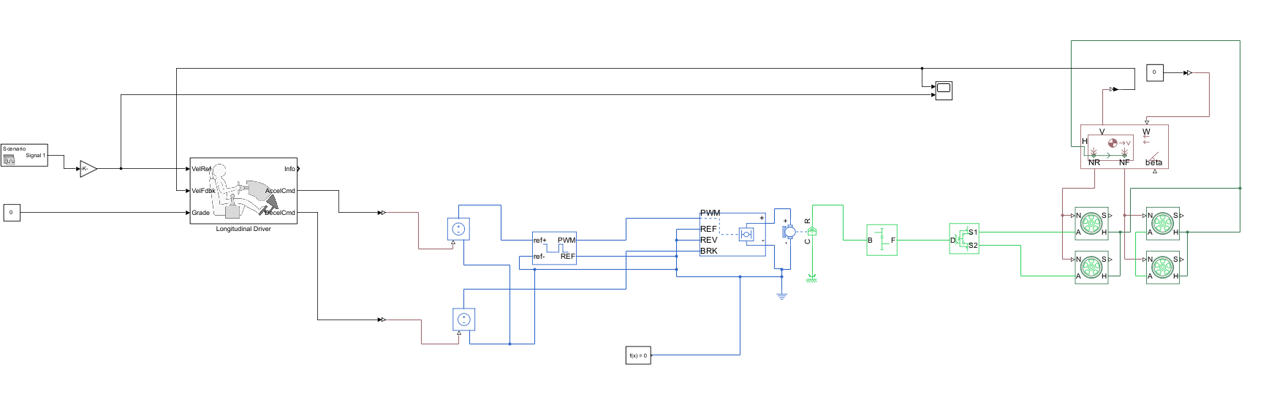

Overall EV Simulation

* 1. **Vehicle body and Tires:**

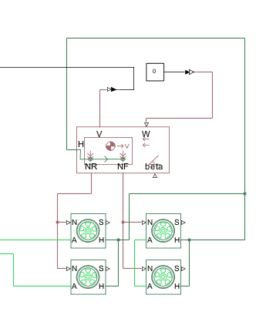

**Simulation of vehicle body and tires**

###### Description

Vehicle Body Block in a Simulink E-Bicycle Model (MATLAB Design)

The vehicle body block described represents the chassis of the e-bicycle in the Simulink model. It interacts with other components to simulate the bicycle's dynamics. Here's a breakdown of the ports and connections:

* + 1. **Vehicle Body Block:**
       - Ports:
         * Port 1: Normal Reaction (Rear & Front): This port receives the normal force from both the rear and front tires acting perpendicular to the ground.
         * Port 2: Normal Traction (Rear & Front): This port receives the longitudinal force from both the rear and front tires acting in the direction of motion (traction) or opposite (braking).
         * Port 3: β (Inclination of Road): This port receives the road inclination angle (beta) to account for uphill or downhill slopes.
         * Port 4: H (Hub): This port connects to the hub block, representing the rotational connection between the wheels and the chassis.
         * Port 5: v (Output Velocity): This port outputs the overall linear velocity of the e-bicycle.
         * Port 6: w (Wind Resistance): This port receives the wind resistance force acting on the e-bicycle.

**The longitudinal force (F_x)** acting on the vehicle body represents the force that propels the vehicle forward (positive) or brakes it (negative). It's primarily influenced by:

* + - * **Motor torque (T_m):** The torque generated by the electric motor.
      * **Wheel rolling resistance (F_rr):** The force resisting the rolling motion of the wheels due to tire deformation and road surface friction.
      * **Aerodynamic drag (F_drag):** The air resistance against the vehicle's movement.
      * **Grade resistance (F_grade):** The force due to the incline of the road (positive uphill, negative downhill).

**Vertical Force:**

**The vertical force (F_z)** acting on the vehicle body represents the normal force exerted by the road on the tires, supporting the vehicle's weight. It's primarily influenced by:

* + - * **Vehicle mass (m):** Total mass of the vehicle (including passengers and cargo)
      * **Gravitational acceleration (g):** Constant acceleration due to gravity (9.81 m/s²)
    1. **Tires (Magic Formula):** The vehicle body connects to four magic formula tire models.
* Each magic formula tire model likely has four ports:
  + Normal Reaction: Receives the normal force from the vehicle body (Port 1 connection).
  + Excitation: Receives the driving/braking torque input (likely connected to motor torque output).
  + Hub: Connects to the vehicle body's hub port (Port 4 connection).
  + Output Slip: Outputs the tire slip, a measure of how much the tire is sliding relative to the ground.

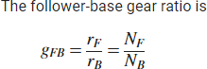

where:

* + - * *NB* is the number of teeth in the base gear.
      * *NBF* is the number of teeth in the follower gear.
      * *rF* is the radius of the follower gear
      * *rB* is the radius of the base gear.
    1. **Gears:** A simple gear model can be connected to modify the motor torque before it reaches the magic formula tires (excitation port).
    2. **How This Works for E-Bicycle Simulation:**

1. The electric motor generates torque based on the control signal (usually from a driver model or logic controller).
2. This torque is transmitted through a gearbox or differential (gear model), which alters the torque and speed according to the gear ratio, and then passes it to all four Magic Formula Tire models (Excitation Port).
3. Each Magic Formula Tire model simulates the tire-road interaction for one wheel, considering inputs such as normal force (Port 1 connection) and wheel slip to compute traction and braking forces individually for all four wheels.
4. The calculated tire forces are then provided to the Vehicle Body 3DOF block through Port 2 connections, influencing the vehicle’s longitudinal and lateral motion.
5. Simultaneously, the Vehicle Body block receives:  
   1. Normal forces from each tire (Port 1 connections)
   2. Road gradient or slope affecting the vehicle (Port 3 connection)
   3. Aerodynamic drag or wind resistance (Port 6 connection)
6. Based on all these forces and resistances, the Vehicle Body block computes the overall vehicle dynamics, including:  
   1. Linear velocity and position (Port 5 connection)
   2. Yaw rate and lateral movement, especially during turning or braking
      1. **Parameters:**

Below figure(3.1.1) shows the parameters of Vehicle body where we have kept Mass of body 110 kg, number of wheels per axle 1, horizontal distance from CG to front axle is

.65m, horizontal distance CG to rear axle is .44m and drag for frontal area is 5.5ft^2, drag coefficient is 1.1 and air density 1.25kg/m^3.

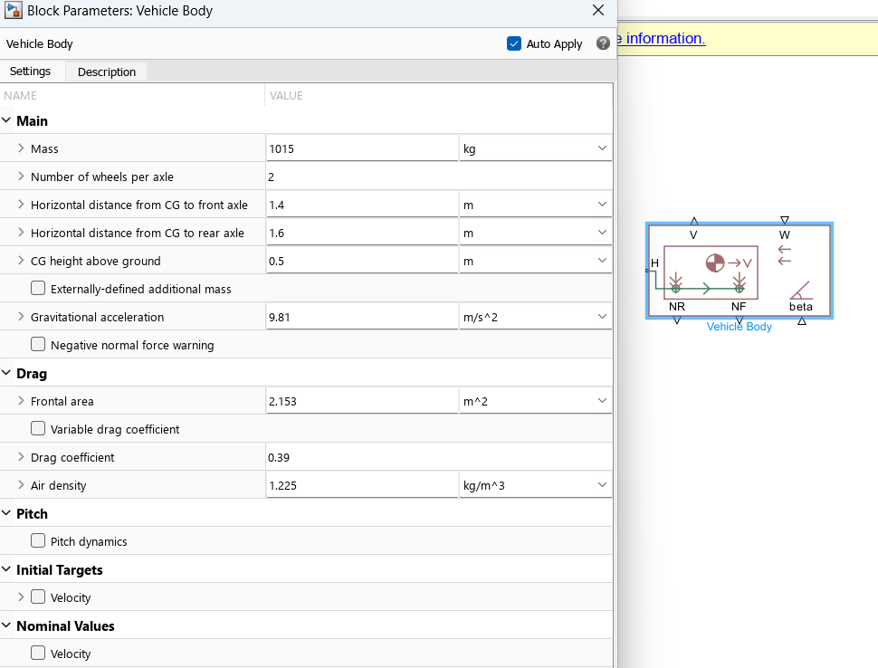

Figure 3.1.1

Below Figure(3.1.2) shows the parameters of tires where we have kept rated vertical load 3000N and peak longitudinal load 3500 N and coefficient for rolling resistance is 0.013.

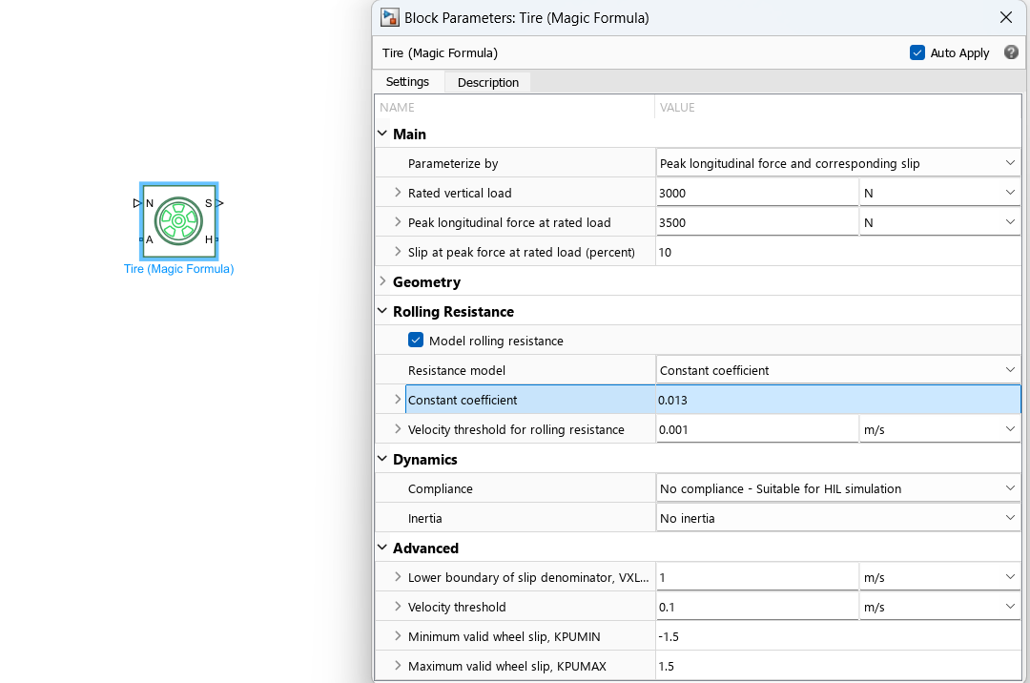

Figure 3.1.2

## Motor and Controller:

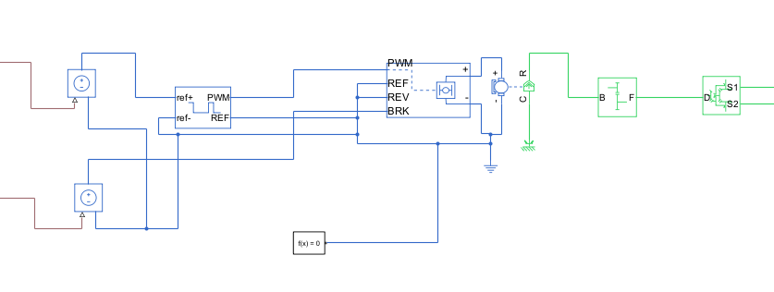

Simulation of Motor and Controller

Here's a breakdown of the motor, controller, and PWM block in your Simulink e-bicycle model and their role in controlling the motor:

* + 1. **Motor:**
       - Ports:
         * Port 1: Shaft to Gear Output: This port outputs the rotational speed and torque of the motor shaft, which is connected to the vehicle body block (likely Port 4: Hub).
         * Port 2: Body: This port is likely a mechanical reference for the motor, typically grounded.
         * Port 3: Positive: This port receives the positive voltage from the battery.
         * Port 4: Negative: This port receives the negative voltage from the battery, completing the electrical circuit.
    2. **H-Bridge Controller:**
       - Ports:
         * Port 1: PWM: This port receives a Pulse Width Modulation (PWM) signal to control the motor's direction and speed.
         * Port 2: Reference: This port might be unused in your model. It can be used for an external reference signal for speed control.
         * Port 3: Reverse: This port, when activated (likely with a high voltage), allows the motor to rotate in the reverse direction.
         * Port 4: Brake: This port, when activated (likely with a high voltage), may engage a braking mechanism on the motor or disconnect the motor from the power supply.
    3. **Controlled PWM Block:**
       - This block likely generates a PWM signal based on user input.
         * Left input: Represents acceleration (positive voltage) and sends a higher duty cycle PWM signal to the H-bridge controller (Port 1).
         * Right input: Represents deceleration (positive voltage) and likely sends a lower duty cycle PWM signal or a specific braking signal to the H-bridge controller (Port 1 or Port 4).
    4. **How This Works for E-Bicycle Control:**

1. Driver Input & Command Interpretation:
   * + - * The driver model or user interface captures inputs such as acceleration, deceleration, or braking from the throttle and brake pedals.
         * These inputs are interpreted as analog signals (ranging from 0 to 100%) and passed to a Controlled PWM (Pulse Width Modulation) block that modulates the power delivery to the motor.
         * Controlled PWM Signal Generation:
       1. The Controlled PWM block converts the analog input into a digital PWM signal by adjusting the duty cycle (i.e., the proportion of ON-time in each cycle).  
          - High duty cycle (e.g., 80–100%): Indicates strong acceleration. The switches are ON for longer durations, allowing more voltage and current to reach the motor, resulting in higher torque and speed.
          - Medium duty cycle (e.g., 40–60%): Indicates cruising or partial acceleration. The power delivered to the motor is moderate.
          - Low duty cycle (e.g., 10–30%): Represents deceleration. Less energy is sent to the motor, reducing torque.
          - Duty cycle near 0% or a specific braking input: Indicates full braking, which could either cut off the power supply completely or activate regenerative braking depending on system logic.
          - H-Bridge / Inverter Control (Port 1 Connection):
2. The PWM signal is fed to an H-bridge inverter or power electronics converter, which interprets the PWM signal to manage:  
   1. Switching of power MOSFETs or IGBTs
   2. Polarity and magnitude of the current supplied to the motor
3. The inverter regulates:  
   1. Direction of current (forward or reverse rotation)
   2. Power level supplied (based on PWM duty cycle)  
      * + - Motor Behavior Based on H-Bridge Output:
        1. The motor responds to the voltage and current dictated by the H-bridge:  
           + Forward motion: The H-bridge drives current in the positive direction.
           + Reverse motion (if enabled): The H-bridge reverses the polarity of the current, rotating the motor in the opposite direction (useful for reversing the car).
           + Regenerative braking: If the vehicle is decelerating or moving downhill, the motor operates as a generator, sending power back to the battery system, improving energy efficiency.
           + Braking / Cutoff: If a full stop is needed, the H-bridge either disconnects the motor from the power source or shorts the motor terminals (plug braking), applying an electrical braking torque.

* + - * + Feedback and Dynamics:

The torque generated by the motor is passed to the gearbox or differential, then to the wheels through the drivetrain.

Each wheel is modeled using a Magic Formula Tire model that computes traction, slip, and braking forces.

These forces are fed to the Vehicle Body block, which uses them (along with normal forces, road grade, and aerodynamic drag) to compute:

Longitudinal and lateral dynamics

Yaw rate, velocity, and displacement

Energy consumption and efficiency

### Key Features of This Control Scheme:

* **Fine-Grained Motor Control:** PWM allows precise control over motor torque and speed.
* **Bidirectional Operation:** Supports both driving and regenerative braking modes.
* **Energy Efficiency:** Braking energy can be recovered and stored in the battery.
* **Scalability:** The same logic can be extended to dual-motor or all-wheel-drive EVs

**3.2.5. Parameters:**

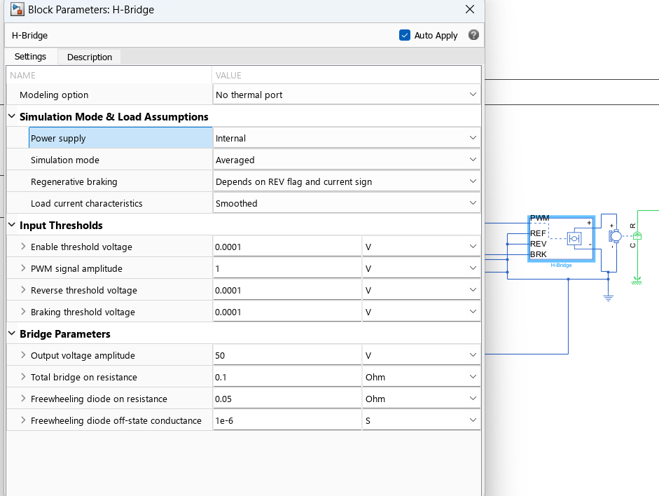

Figure 3.2.1

Above figure(3.2.1) shows the parameters of H-Bridge where we have kept power as internal, PWM signal amplitude as 1V and output voltage as 50V.

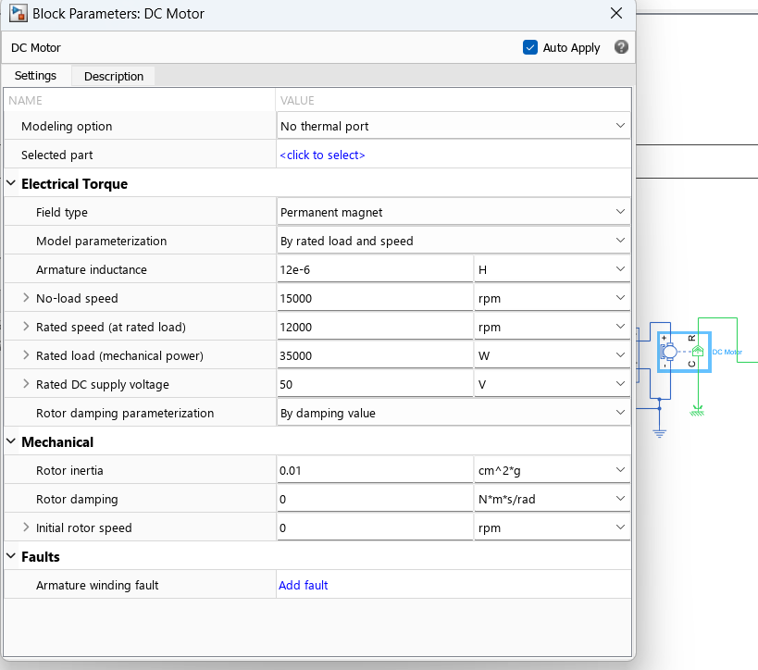

Figure 3.2.2

Above figure(3.2.2) shows the parameters of DC Motor where we have kept No-load speed at 15,000rpm, rated speed 12,000rpm, rated load 35000W and supply voltage is 50V.

## Driver Input:

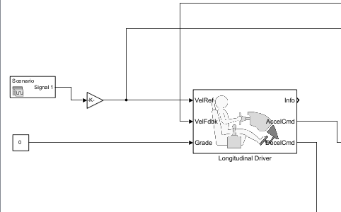

Simulation of Driver input

* + 1. **Longitudinal Driver Block:**
       - **Ports:**
         * **Port 1:** Reference Velocity: This port receives the desired e-bicycle speed as an input from the user or another source (e.g., signal builder).
         * **Port 2:** Feedback Velocity: This port receives the actual e-bicycle speed from the vehicle body block (likely Port 5: Output Velocity). This is used for closed-loop control.
         * **Port 3:** Grade: This port receives the road inclination angle (grade) to account for uphill or downhill slopes.
         * **Port 4:** Acceleration Command: This port outputs a voltage control signal based on the acceleration command.
         * **Port 5:** Deacceleration Command: This port outputs a voltage control signal based on the deceleration command.
         * **Port 6:** Information: This port might output additional information about the driver's input or control strategy.
    2. **Multiple Switch:**
       - This block likely allows you to choose the source of the reference velocity for the driver block (Port 1).
       - **Ports:**
         * **One port connected to a constant:** This allows you to set a fixed reference velocity for testing purposes.
         * **One port connected to a Drive Cycle Source (Manhattan Bus Cycle):** This allows you to simulate the e-bicycle's performance under a realistic driving scenario, such as a Manhattan bus cycle which represents frequent stops and starts.
         * **One port connected to a Signal Builder:** This allows you to create a custom reference velocity profile for specific research purposes.
    3. **P-S Controllers:**
       - The driver block likely uses two P-S (Proportional-Integral) controllers internally.
         * **Acceleration Command (Port 4):** This controller calculates the voltage command to the motor controller (via H-bridge) based on the difference between the desired speed (reference velocity) and the actual speed (feedback velocity). A positive difference (desired speed > actual speed) triggers acceleration.
         * **Deceleration Command (Port 5):** This controller calculates the voltage command for deceleration or braking. A positive difference (desired speed

< actual speed) might trigger regenerative braking or motor braking depending on your model setup

* + 1. **Parameters:**

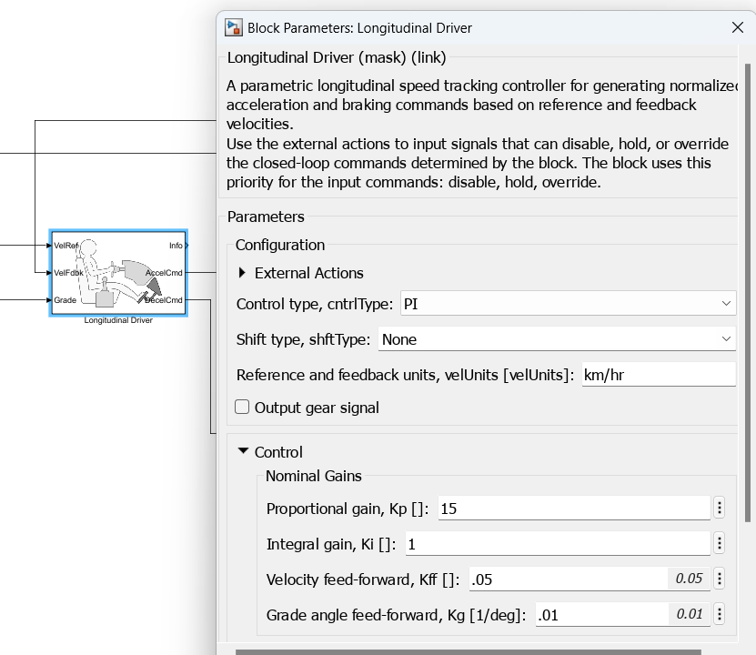

Figure 3.3.1

## Signal Generating Subsystem:

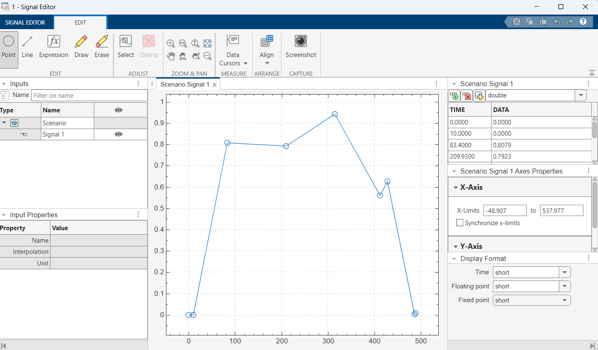

The block creates one port for each signal.

To create and edit scenarios and the signals contained in the scenarios, click Open Signal Editor (). You can also use the Signal Editor block to switch scenarios in and out of models.

The Signal Editor block supports MAT files that contain signals as one or more scalar Simulink.SimulationData.Dataset objects.

* + 1. **Battery and Power Delivery:**
       - The battery pack in your model represents the e-bicycle's energy source, providing power to the motor through connections within the subsystem.
       - The chosen lithium-ion battery allows for direct access to the SOC percentage within Simulink.
    2. **Importance of SOC:**
       - SOC is a crucial parameter that reflects the remaining battery capacity. It indicates how much longer the e-bicycle can operate before requiring a recharge.
       - By monitoring SOC throughout the simulation, you can gain valuable insights into:
         * **Riding Range:** Analyze the e-bicycle's potential distance under various conditions based on battery depletion.
         * **Battery Usage:** Evaluate how different control strategies and driving styles affect battery consumption.
         * **Recharge Cycles:** Understand how frequently the battery needs recharging based on simulated usage patterns.
    3. **Simulating Battery Charging and Discharging:**
       - Analyzing SOC allows you to examine both battery charging and discharging behavior within the simulation.
         * During discharge (e-bicycle operation), SOC decreases as the battery delivers power to the motor.
         * By incorporating a charging mechanism (future work), SOC can be observed to increase during simulated charging cycles.
    4. **Sub-System Connections:**

The provided diagram (not shown here, but you can reference it in your paper) should illustrate the connections between the battery block and other components within the sub-system.

* + - * The battery likely connects to:
        + The motor controller: Supplying power to the motor based on control signals.
        + An SOC calculation block: Continuously calculating the remaining battery capacity based on current and voltage.
        + Possibly other monitoring blocks (optional): Recording data like battery voltage and current for further analysis.
    1. **Parameters:**

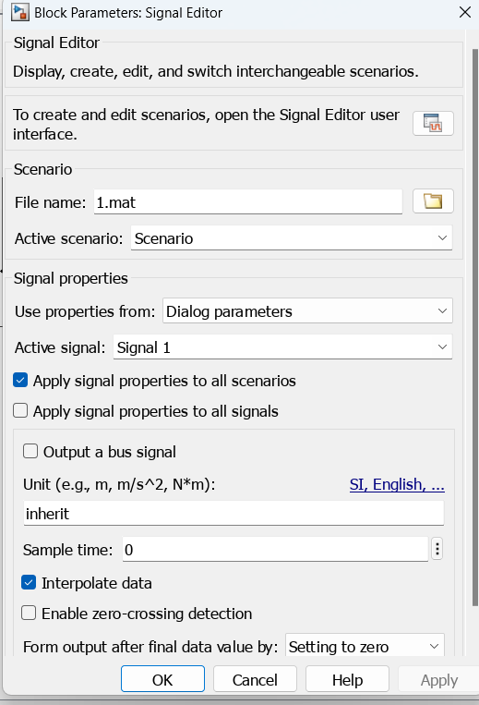

# Chapter 4: Simulation Results

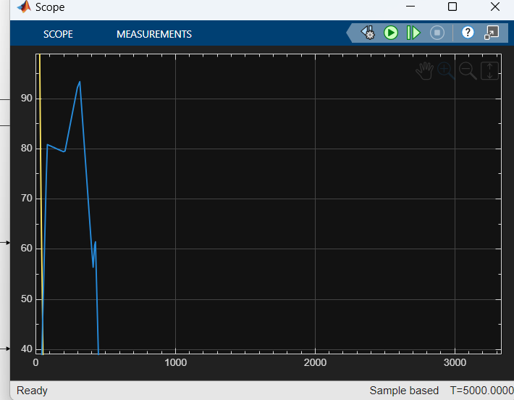

# Chapter 5: REGENERATIVE Braking system simulation

### Regenerative Braking System (RBS)

Regenerative braking is a key technology in electric and hybrid vehicles that improves energy efficiency by converting the vehicle's kinetic energy into electrical energy during deceleration. Instead of dissipating this energy as heat (as in traditional brakes), RBS uses the electric motor as a generator to recover energy and store it in the battery.

This system includes components like a motor-generator, power electronics controller, and battery pack. During braking, the controller switches the motor to generator mode, allowing current to flow back into the battery.

**Benefits** include increased range, reduced brake wear, and enhanced efficiency. However, RBS is less effective at low speeds and requires sophisticated control algorithms to blend with friction brakes safely.

In the simulated electric vehicle drivetrain during this internship, regenerative braking was modeled to assess its impact on battery SOC (State of Charge), energy recovery during deceleration, and overall efficiency improvement.

